2.1. CREATE INITIAL DESIGN CLASSES

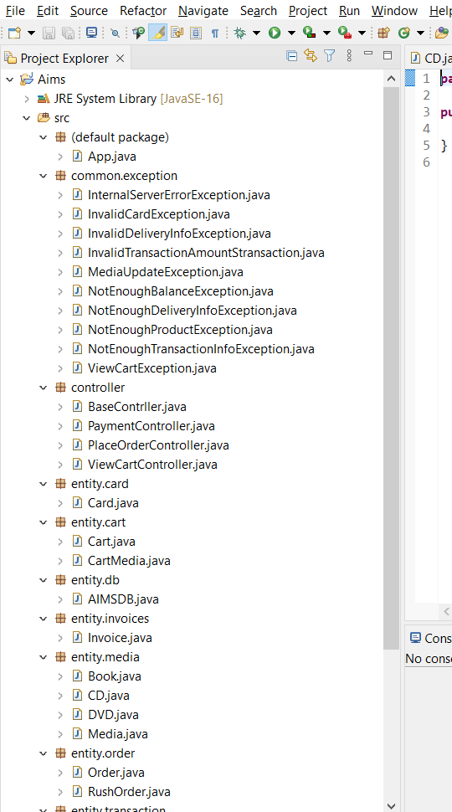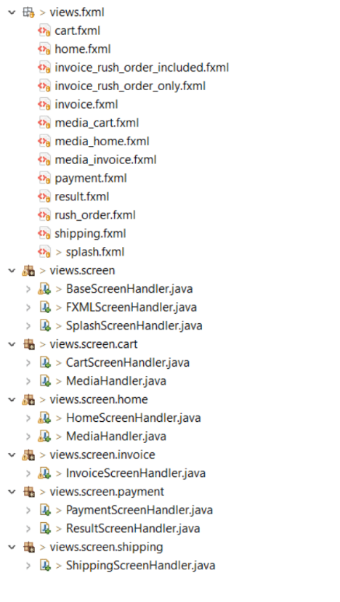

2.2. DEFINE RELATIONSHIPS BETWEEN CLASSES

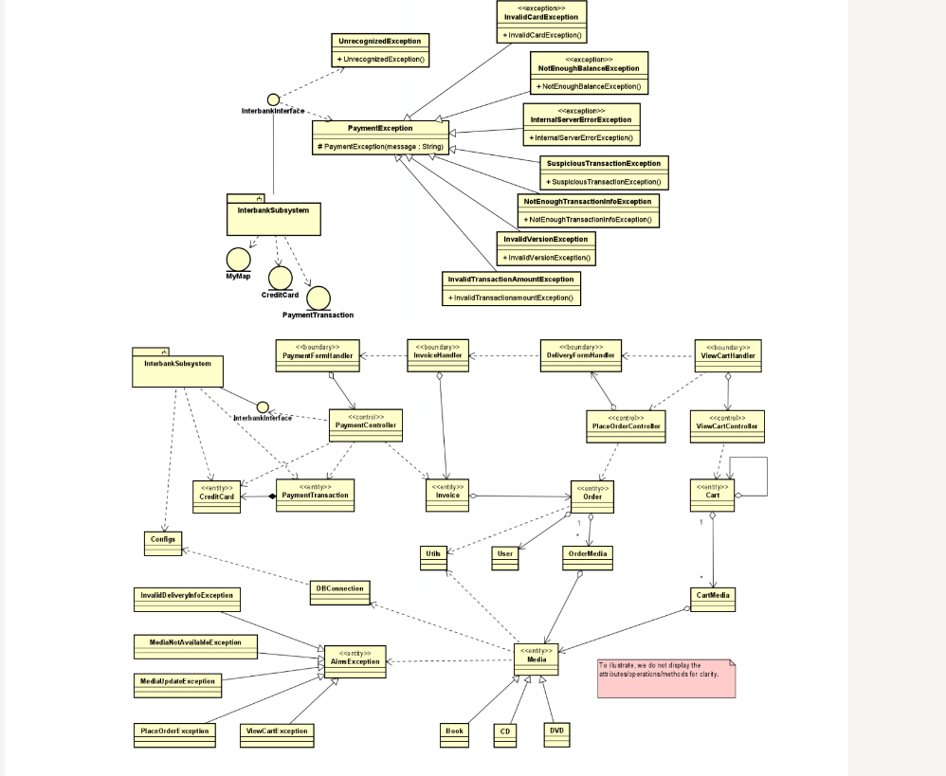

2.3. CLASS DESIGN

2.3.1

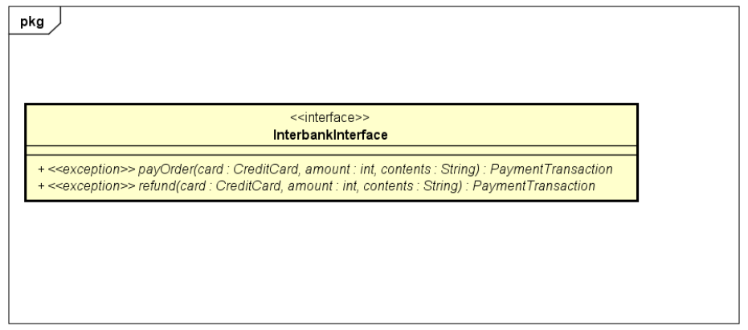

Attribute

None

Operation

|  |  |  |  |
| --- | --- | --- | --- |
| # | Name | Return type | Description (purpose) |
| 1 | payOrder | PaymentTransaction | Pay order, and then return the payment transaction |
| 2 | refund | PaymentTransaction | Refund, and then return the payment transaction |

Parameter:

- card – the credit card used for payment/refund

- amount – the amount to pay/refund

- contents – the transaction contents

Exception:

- PaymentException – if responded with a pre-defined error code

- UnrecognizedException – if responded with an unknown error code of sonething goes wrong

Method

None

State

None

**2.4. CLASS DIAGRAM**

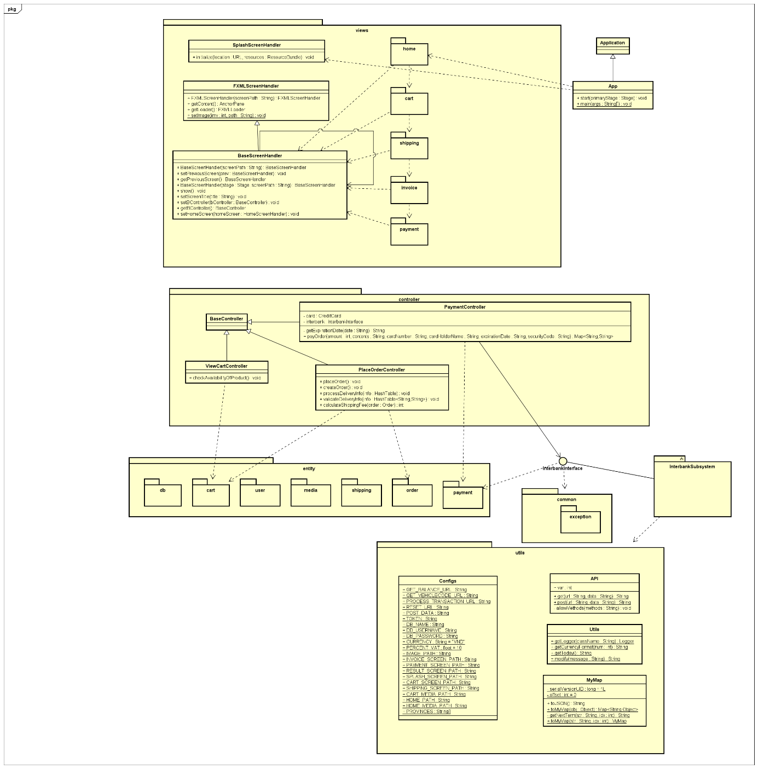

**2.5. CLASS DESIGN FOR “PLACE RUSH ORDER”**

2.5.1. Class Diagram

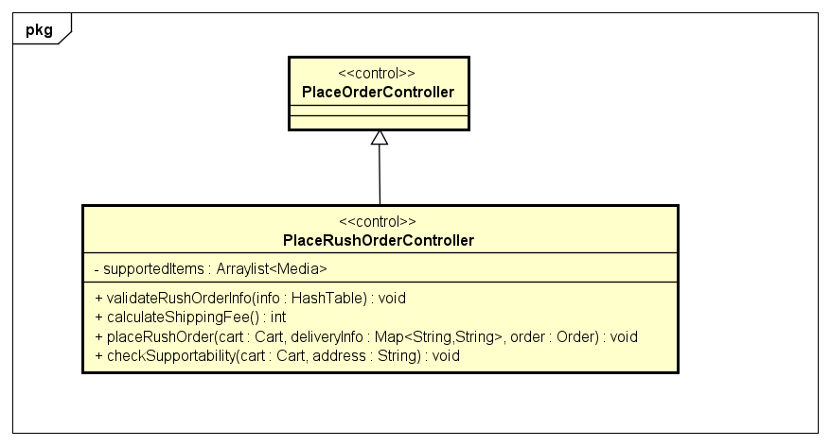

2.5.2. Attribute

|  |  |  |  |  |
| --- | --- | --- | --- | --- |
| No | Name | Type | Default value | Description |
| 1 | supportedItems | Arraylist<Media> | NULL | A list of Media which support rush order shipping |

2.5.3. Operation

|  |  |  |  |
| --- | --- | --- | --- |
| No | Name | Return type | Purpose |
| 1 | placeRushOrder | void | Place rush order |

Parameters:

- cart: represent user’s shopping cart with products to place order

- deliveryInfo: information about delivery

- order: the order to be made

|  |  |  |  |
| --- | --- | --- | --- |
| No | Name | Return type | Purpose |
| 2 | validateRushOrderInfo | void | Validate user input for placing rush order |

Parameters:

- info: user input

|  |  |  |  |
| --- | --- | --- | --- |
| No | Name | Return type | Purpose |
| 3 | calculateShippingFee | int | Calculate shipping fee for rush order |

Parameters: None

|  |  |  |  |
| --- | --- | --- | --- |
| No | Name | Return type | Purpose |
| 4 | checkSupportability | void | Check if there is any item supported by rush order or the address is supported, then make a list of items supported by rush order |

Parameters:

- cart: represent user’s shopping cart with products to place order

- address: user’s delivery address

2.5.4. Method

None

2.5.5. State

None

**2.4. CLASS DIAGRAM**



**2.5. CLASS DESIGN FOR “PLACE RUSH ORDER”**

2.5.1. Class Diagram



2.5.2. Attribute

|  |  |  |  |  |
| --- | --- | --- | --- | --- |
| No | Name | Type | Default value | Description |
| 1 | supportedItems | Arraylist<Media> | NULL | A list of Media which support rush order shipping |

2.5.3. Operation

|  |  |  |  |
| --- | --- | --- | --- |
| No | Name | Return type | Purpose |
| 1 | placeRushOrder | void | Place rush order |

Parameters:

- cart: represent user’s shopping cart with products to place order

- deliveryInfo: information about delivery

- order: the order to be made

|  |  |  |  |
| --- | --- | --- | --- |
| No | Name | Return type | Purpose |
| 2 | validateRushOrderInfo | void | Validate user input for placing rush order |

Parameters:

- info: user input

|  |  |  |  |
| --- | --- | --- | --- |
| No | Name | Return type | Purpose |
| 3 | calculateShippingFee | int | Calculate shipping fee for rush order |

Parameters: None

|  |  |  |  |
| --- | --- | --- | --- |
| No | Name | Return type | Purpose |
| 4 | checkSupportability | void | Check if there is any item supported by rush order or the address is supported |

Parameters:

- cart: represent user’s shopping cart with products to place order

- address: user’s delivery address

2.5.4. Method

None

2.5.5. State

None